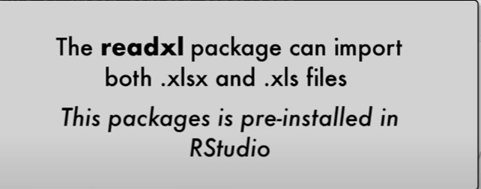

The readxl package makes it easy to get data out of Excel and into R from multiple worksheets and clean up the data before importing it (like change the name, skip rows and columns, identify the type of the data, and many more useful functions)

U can import the data either by

1. File 🡪 Import dataset 🡪 From Excel
2. Environment 🡪 Import dataset 🡪 From Excel

N0TE: After finishing the adjustments required for the date, copy the script and save it, so u can import the date immediately the next time. They u can run it.